

Team Leader

Joseph Jimenez

Team Members

Thanh Tran, Christopher Vu, Daniel Contreras

Professor: Ahmed Alweheiby

CMPR 154

November 22, 2024

The following project is a guessing game, which is common for many beginner programmers' projects begin with. The twist with this guessing game is that it runs on a low- language called Assembly. Specifically, this project is running on Microsoft Macro Assembler (MASM), an x86 assembler that uses Intel syntax for the Windows operating system. Using MASM, the library of choice is Irvine32, which provides a convenient set of library of functions. This makes simple input/output processes less redundant. Each member had a role that involved coding the program, input validation, testing for any bugs, and documentation. The team lead was in charge of making sure that the program was finished before the project's due date.

The objective of this game is to have the user guess a number between one to ten. If the user guesses correctly, two credits will be added to their account. If the user guesses incorrectly, one credit will be taken from their account. Each user will be asked for their name at the start of the program to keep track of the user statistics. After inputting their name, the main menu will display following our title screen. The user can select between options one to five, each with their own specific role. Option one will display the available credit to the user; it will have an updated amount on each win or loss. The second option is where user can add credit to their account. The maximum capacity is twenty, and the program will validate the user input to check if it is valid or invalid. Option three is the game itself, where user will input a number between one to ten and determine if the random generate number is the same as the user input. User will either gain or lose credit in this section. In addition, this option will ask the user if they would like to play again. Option four is the user statistics; their name, game played, and wins and losses are displayed. Lastly, Option 5 is the quit option which exits the program.

Overall, the main issue was the complexity of using assembly language for the first time, especially compared to high-level language counterparts. Secondly, using the jump operators posed a reoccurring challenge; if not used carefully, it can be difficult to find the error. Thus, the project was a great interactive experience of what goes on under the hood of programming languages.

Start of the program

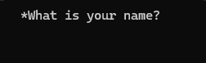

Main Menu

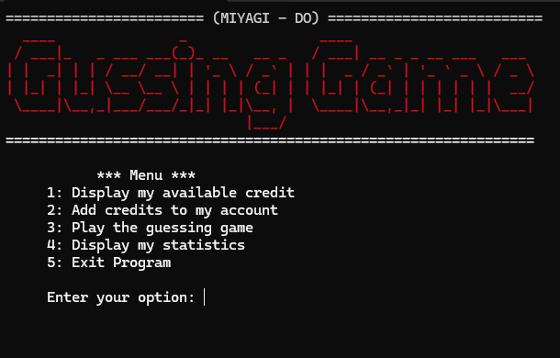

Option 1: Display available credit

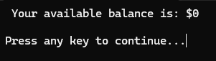

Option 2: Add credit to account

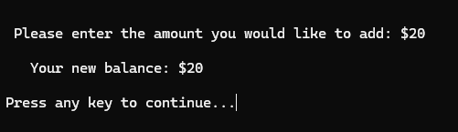

Option 3: Play game ( I got the incorrect answer)

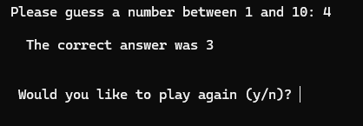

* User will be prompt to play again

Option 4: User Stats

* In this case it removed 1 credit from my account

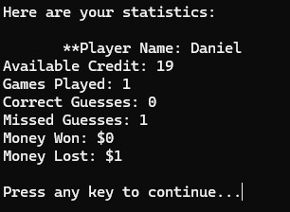

Option 5: Exit

